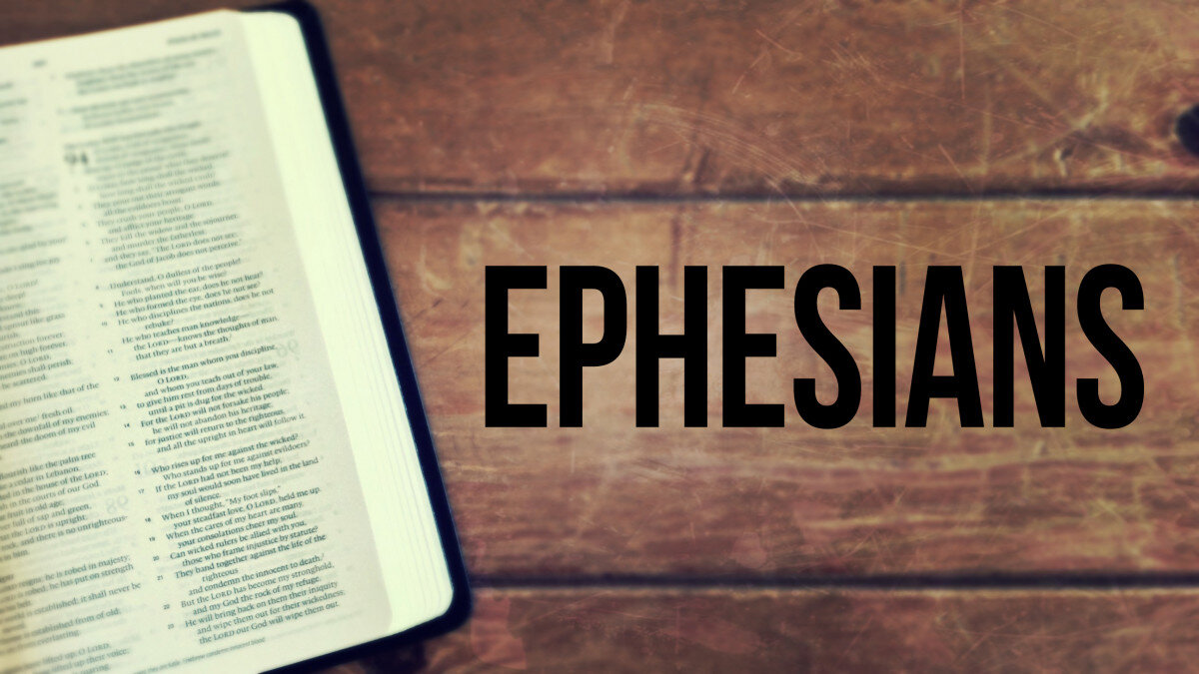

**The Journey and Joy of Inductive Bible Study**

Greetings, friends. You are about to learn a method of Bible study that could bring tremendous growth and maturity in your walk with Christ. As you begin, my prayer for you is that through the study of God’s Word, the Lord would grow you, move you, and fill you to accomplish mighty things for His purpose. I pray you will persevere, and not lose heart but hold onto the principles of God’s Word as the Spirit of God leads you into all truth.

The Bible tells us everything we need to know about life and purpose. Because **as long as you have a pulse, God has a purpose for you worth living for**. There are many ways to study the Bible, with many excellent aids to further your spiritual growth. But the most important thing you need to remember is to find out **what the Bible says**, **what it means**, and **how you are to apply it to your life**. The best way to do this is through the process called Inductive Bible Study. So, get ready for the journey of a lifetime as you and your church equip one another for the glory of God.

**Beginning with the Basics**

Inductive Bible study consists of three key components which we will look at separately. These three parts are **Observation, Interpretation,** and **Application.**



**OBSERVATION** – Asks the question: What does the passage say? (Don’t read into it) What do you see in the passage that stands out to you? Look for key words, phrases, comparisons or contrasts. You are asking the questions – Who? What? Where? When? How? and Why?

*Observation teaches you to see exactly what the passage says. It is the basis for accurate interpretation and correct application.*

*In observation, you assume the role of a biblical detective, looking for clues. Howard Hendricks*



**INTERPRETATION –**Asks the Question**:** What does the passage mean?What’s the author’s main intent or purpose in sharing this truth?

Imagine you’re in a car heading back to your village or town and you look out the window and see a man jumping up and down waving his hands in the air. What are you thinking?

* **You might be thinking. . . that man needs help.**
* **Or that man is drunk**
* **Or that man is being friendly.**

There may seem to be many reasons why the man is acting this way, but we can’t know the real reason for his behavior unless he explains it to us. We can be sure of this, there is only one correct interpretation as to why this man is waving his arms. It is our quest to find out the meaning of why this man is doing this.

**So, it is with correct interpretation of the Word of God. There is only one correct interpretation of a passage, but many applications.**



**APPLICATION –** Asks the question: How can I put this into practice? How can I apply this to my life, marriage, family, church, workplace, etc.

Questions you might ask when applying a passage:

* Did anything in this passage capture my attention?
* What did I like about this passage?
* Did anything bother me? Why?
* What does this passage tell me about God?
* What does this passage tell me about man?
* Are there principles about sin that I need to avoid?
* What does this passage tell me about living to please God?
* How might this passage change the way I act?
* Are there commands to obey or examples to follow?
* What principles in this passage/story need to be shared to someone who doesn’t know Jesus?

As you diligently study God’s Word, under the guidance of the Holy Spirit, it will be like a strong anchor which holds in the storms of life. The Inductive Bible Study method will help you in having a more meaningful and authentic walk with Christ and others as you do great things for His glory.

***2 Timothy 2:15***