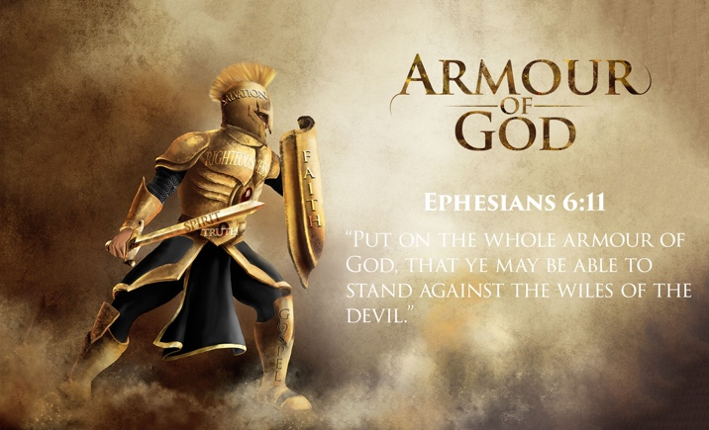**BATTLE READY!**

Ephesians 6:10-24

Session 13

We are engaged in a spiritual battle of evil forces which wants to prevent us from living a spirit-filled life. Satan, like a thief desires to steal our joy, kill our passion and destroy our character. In this session Paul tells us how we can we guard ourselves by staying strong in the Lord and in the power of His might?

**Ephesians 6:10-24**

* Read the passage on your own.
* If you’re in a group have someone read it out loud.
* Have someone summarize what was just read
* How many times does Paul tell us as believers to “put on” or “take up” or “stand against”?



**Observations - What do I see?**

* What are some key words or phrases that stand out to you in this passage?
* From these verses, how does the enemy work to try to prevent us from being effective for the Lord?
* What are ways we can defend ourselves from the tactics and deceptions of the enemy?

***Helpful Notes*:** Whenever it comes to dealing with the devil, we tend to make two mistakes.

1. **We underestimate Satan.** Satan wants us to think that he is not dangerous, or that he doesn’t exist, or to think we can overpower him in our own strength. By underestimating his power and tactics we can quickly find ourselves falling into his trap.
2. **We overestimate Satan.** Satan is not God's equal. He's infinitely inferior. He is a created being who allowed his pride/ego and 1/3 of the angels in heaven to be kicked out of heaven. Yes, he has power, but God is greater! 1 John 4:4 tells us, "You are of God, little children, and have overcome them, because He who is in you is greater than he who is in the world." Remember Satan is a defeated foe. The only time the devil can hassle a Christian is when we let him. We need to rise up as James 4:7 tells us, "Resist the devil and he will flee from you." On your own, you're no match for the evil One, but Paul says, “be strong in the Lord and in the power of His might.” Let’s be strong!

Paul helps us to see how we can defend ourselves from the enemy

**Analyze your enemy vs. 10-12**

As believers we need to know the tactics our enemy is trying to use on us. Paul calls them “the wiles or schemes of the devil” - doubt, fear, jealousy, condemnation, discouragement, dissension. Satan will do all he can to distract you from who you are and what you have in Christ. The devil wants to undermine our faith and rob us of our blessings, joy and peace in Christ.



**Talking it over -Group Study:**

What are we instructed to do in these verses?

Why is our struggle not against flesh and blood?

**Utilize the Armor of God vs. 13-17**

God gives us armor, “Therefore take up the whole armor of God, that you may be able to withstand in the evil day, and having done all, to stand.” While Paul wrote this letter to the Ephesians he was chained to a Roman soldier. So Paul uses the gear issued by the Roman Legion as analogous to our spiritual armor... Look at the armor the Lord has given us to put on daily.

**The Belt of Truth**. The belt secures the other pieces of armor. Loose loins going into battle can get you killed. Truth should surround us like a belt. The belt of truth is the antidote to Satan’s lies and deception. The belt of truth keeps us honest with others, our God, and ourselves. Knowing the truth and living the truth sets us free from false teaching which comes from Satan himself.

**Question:**

Why is truth so important in spiritual battle? (See Ephesians 4:14; 1 Peter 1:13-16)

How can untruths (lies) hinder us in spiritual battle?

**The Breastplate of Righteousness**. The ancients viewed the heart as the seat of the desires. And for Paul, the heart needed to be protected. We need to nurture and cultivate godly desires. Without righteousness we leave ourselves vulnerable to Satan’s attacks. The breastplate which a Roman guard wore, covered the front and back of him from neck to waist. Be on guard (See Proverbs 4:23; 1 Peter 2:11-12). Remember you're not the same person you used to be - your deepest desires have changed.

**Question:**

What might be some old desires which you need to guard your heart from which the enemy tries to put in front of you?

**Spiritual Footwear**

“And having shod your feet with the preparation of the gospel of peace...” The Roman soldier wore a unique type of sandal. Their soles had stubs so the soldier wouldn't slip on the rocky terrain. At times, we can get blindsided and knocked off balance. Someone attacks our faith with questions we can't answer. We become confused and are tempted to doubt. In such times, we need to rest in God’s peace. When there is confusion in your head, recall the peace in your heart. No one can deny the presence of God that you sense, and the miracle Christ has done in you. Let God's peace steady your faith.

**Question:**

How does the enemy try to knock you off balance by robbing you of your peace?

What can you be reminded of when this happens?

**The Shield of Faith**

“Above all, taking the shield of faith with which, you will be able to quench all the fiery darts of the wicked one.” The Roman shield was big enough to protect a soldier from a shower of flaming arrows. He crawled under the shield and waited out the attack. Satan often tries to shower us with flaming arrows of doubt, discouragement, lust, and guilt. In those moments, we need to hold up our faith and trust the Lord no matter what. Rest in the great faith you have in Christ until the attack has passed.

**The Helmet of Salvation**

Just as you wear a helmet when on a motorcycle to protect you, so we are instructed by Paul to wear the helmet of salvation guarding our minds from unhealthy negativity the enemy throws at us. Paul tells us in Colossians 3:2, "Set your mind on things above, not on things on the earth." Wear a helmet! In doing so we can focus on the incredible sacrifice of His son Jesus Christ who provided salvation for everyone who will put their trust in Him.

**Two Offensive Weapons vs. 17-18**

* **The Sword of the Spirit**.

Every Roman soldier would carry a sharp two-foot sword for close combat when in battle. A sword is no good if not picked up and wielded. God has given us His Word as a powerful weapon when standing up to the enemy. Jesus used the power of His Word when He was tempted in the wilderness (See Matthew 4:1-11) Read his Word-----Know His Word-----Live out His Word!!! The sword of God’s Word shreds the lies of Satan but also upholds the truth of what is right and pure and praiseworthy (See Philippians 4:8-9)

* **The Power of Prayer.**

“Praying always with all prayer and supplication in the Spirit, being watchful to this end with all perseverance and supplication for all the saints...” Prayer is the heavy artillery that can destroy the enemies’ strongholds.

**Four “all’s” in verse 18**

Pray on all occasions (all times)

Pray all kinds of prayers and petitions

Pray with all perseverance

Pray for all the saints



**Interpretation – Ask a Question:** What’s the author’s main intent or purpose for sharing these truths with us?



**Application – Put into practice**

What parts of the armor of God stand out and minister to you?

How is the enemy trying to shoot his fiery darts at you personally, or your family, or your church? What can you begin to do right now to guard yourself against his tactics?

[**www.equipministriesinternational.org**](http://www.equipministriesinternational.org)