**The New Life of the Disciple** Session 7

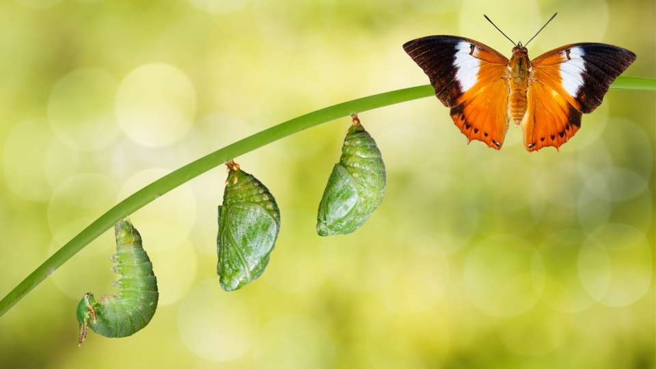

How have your words, actions, and attitude changed as a disciple of Jesus Christ?

The new life of a disciple of Christ is characterized by an internal transformation by the Holy Spirit, resulting in an external demonstration of the fruit of the spirit. In this session we will examine the way in which we are transformed from our old life to our new life in Christ as His follower.

**Group Exercise:** Look up Ephesians 5:1-21

Read the passage to yourself and then have someone in the group read it out loud.

**Observation** – What do you see in the passage that stands out?

Look for key words, phrases, comparisons, or contrasts that stand out to you?

It’s important to understand the background of the passage you are examining. Who is writing the letter? What is happening? Where is this taking place, when was this written? Knowing and understanding the background of a letter or book of the Bible helps us move forward with confidence.

**Question**: How many of you have children? Share their names.

***Helpful Notes***: Have you ever seen your children imitate something you or your spouse does? Can you think of something? Kids are natural imitators. They often do or say what they see their parents doing. Children learn best by imitating. This is done by listening, watching, and doing. In the same way, how do we imitate the new life we have in Christ as a disciple of the Lord Jesus Christ.

**In Ephesians 5:1-21, Paul gives five contrasts between the old life we used to live and the new life we now live as a disciple of Christ.**

**OLD LIFE- Put Off** **NEW LIFE- Put On**

Imitator of the **World** Imitator of **God**

**Question:** How are we to be imitators of God from verses 1-2?

Imitating **sexual immorality** Imitating **sexual purity**

**Question**: What is the difference is there between the person who imitates sexual immorality and sexual purity in verses 3-7?

What is Paul talking about when he says in verse 7, “therefore do not be partners with them.”

Imitators of **Darkness** Imitators of **Light**

**Question:** Look at verses 8-14 and discuss all the things that darkness does and all the things that light does.

Imitators of **foolish living** Imitators of **wise living**

**Question**: What character traits might you find in someone who is foolish? What character traits might you find in someone who is wise? (see verses 15-17)

*“And as for you, brothers, never tire of doing what is right.” 1 Thessalonians 3:13*

Imitators of an **out of controlled life** Imitators of a **spirit-controlled life**

Paul in verses 18-21 compares the dangers of drunkenness and being out of control to that of being under the control of the Holy Spirit. What are some of those differences?

**Application: How do I live this out?**

1. Think right, feel right, do right.
2. Guard your heart, for in it is the wellspring of life (Proverbs 4:23)
3. When the heart is right the actions follow and when the heart is not right, the actions follow.
4. As imitators of the new life in Christ ask another believer to hold you accountable to these truths as a disciple of Christ.
5. In what areas mentioned does your church need to be challenged in these truths.

[www.equipministriesinternational.org](http://www.equipministriesinternational.org)