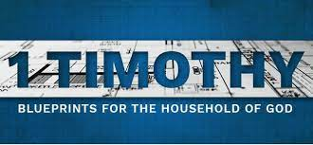
Background on First Timothy:

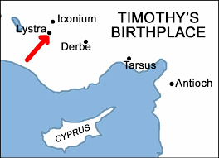
Paul’s first letter to Timothy is essential for any pastor or leader who is leading and directing the church today. Paul spent many years traveling where he either started a new church or visited an existing church plant. He developed a large team of co-workers who desired to advance the gospel for the glory of God. Timothy was one of these leaders. Paul in Acts 16 was in the city of Lystra (see map) and met Timothy’s faithful mother and grandmother (see 2 Timothy 1:5). Paul was impressed by Timothy’s passion and devotion to Jesus. Paul mentored Timothy for many years and referred to him in 1 & 2 Timothy as “my child in the faith.”
1 & 2 Timothy as well as Titus are often referred to as Pastoral Epistles.
The context of 1st Timothy is, Paul had gotten word about a group of leaders who infiltrated the church in Ephesus, and they were spreading incorrect or false views about Jesus and what it means to follow Him. Paul sent Timothy to Ephesus to confront these leaders and restore order to the church. After Timothy arrived there, Paul sent this letter to follow up and instruct Timothy on how to fulfill his mission.
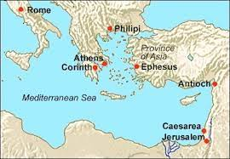
This letter was written by Paul, received by Timothy, and directed to the Ephesian believers. This letter would be read not only by Timothy but would be circulated and read by other churches as well.
Timothy is the pastor of the church of Ephesus – a strategic port city on the Mediterranean Sea on the western edge of modern-day Turkey (see map). Ephesus had a population at this time of around 250,000 and was one of the largest cities of the ancient world. 1st Timothy is 6 chapters – 113 verses – and takes about 20 minutes to read.

Why is First Timothy so important?
First Timothy presents healthy instructions for church pastors and leadership not just in Paul’s day but for us to apply today. This includes sections on appropriate conduct in worship gatherings, the qualifications of elders and deacons, the proper order of church discipline and the taking care of widows. Paul advised Timothy on these practical matters which helped this young pastor grow in his leadership as he equipped the saints for the work of the ministry. (Eph.4:12)
Timothy’s youth. . . a help or a hinderance?
Timothy’s youthfulness was seen as a help but was also viewed by some as a hinderance. His youthfulness was a help in that it allowed him to serve his people with great energy and zeal. But it also caused difficulties with older Christians who may not have taken quickly to the leadership of such a young man because of his lack of knowledge and experience in leadership. It was important to Paul to instruct Timothy in setting an example of consistent faith and a good conscience, remaining above reproach, and exercising the spiritual gifts that God had given him (1 Timothy 4:12-16).

How will this letter challenge the pastor and his people?
As pastors and church leaders we long to see our people grow and mature in their walk with Christ. We desire to see the church strengthened as we live out the Word of God and not be swayed by false teaching. First Timothy helps us to gain a clearer understanding of the proper qualifications and roles for church leadership. Our churches will be strongest when we maintain a healthy understanding of what the Word says and how the church is to be managed. As you look at your church, consider the character and priorities of your leaders, and their doctrine. Are they faithfully living out the Christian faith by example? Applying the truths laid out in First Timothy will enable us to have a ministry that is thriving, not just surviving.

